***Q:no:01: Write a code using***

1. ***Stack object***
2. ***Push these values by push function***
3. ***Pop these values (check with your criteria if not push these values in other stack)***
4. ***Pop from s2 and push in s1***

***Code:***

#include<iostream>

using namespace std;

class stack

{

int a[5];

int top;

public:

stack()

{

top=-1;

}

void show()

{

for(int i=0 ;i<5 ;i++)

{

cout<<a[i]<<"\n";

}

}

void push(int v)

{

if(top<4)

a[++top]=v;

else

cout<<"stack is full....";

}

int pop()

{

if(top>-1)

return a[top--];

else

cout<<"stack is empty"<<endl;

}

};

int main()

{

stack s1,s2;

int n;

for(int i=0;i<5;i++)

{

cout<<"enter "<<i+1<<" number: ";

cin>>n;

s1.push(n);

}

// s1.push(1);

// s1.push(10);

// s1.push(100);

// s1.push(1000);

// s1.push(999);

cout<<"Which value u want to neglect: ";

cin>>n;

int temp;

for(int i=0;i<5;i++)

{

temp=s1.pop();

if(temp!=n)

s2.push(temp);

}

int x;

for(int i=0;i<4;i++)

{

x=s2.pop();

cout<<x<<endl;

}

}

***Output:***

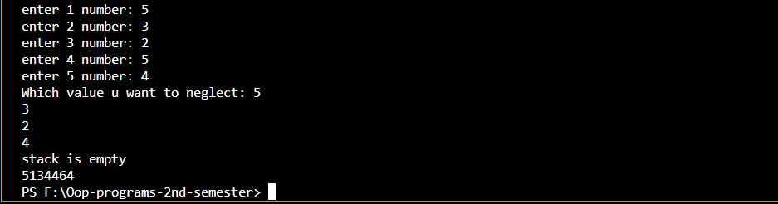

***Q:no:02: Write a code using***

1. ***Stack object***
2. ***Push these values by push function***
3. ***Pop from s1 and push in to other stack on the basis of even and odd***

***Code:***

#include<iostream>

using namespace std;

class stack

{

int a[5];

int top;

public:

stack()

{

top=-1;

}

void push(int v)

{

if(top<4)

a[++top]=v;

else

cout<<"stack is full....";

}

int pop()

{

if(top>-1)

return a[top--];

else

cout<<"stack is empty"<<endl;

}

};

int main()

{

stack s1,se,so;

int n,e=0,o=0;

for(int i=0;i<5;i++)

{

cout<<"enter "<<i+1<<" number: ";

cin>>n;

s1.push(n);

}

for(int i=0;i<5;i++)

{

int temp=s1.pop();

if(temp%2==0)

{

se.push(temp);

e++;

}

else

{

so.push(temp);

o++;

}

}

int x;

cout<<"even stack:"<<endl;

for(int i=0;i<e;i++)

{

x=se.pop();

cout<<x<<endl;

}

cout<<"odd stack:"<<endl;

for(int i=0;i<o;i++)

{

x=so.pop();

cout<<x<<endl;

}

}

***Output:***

